**Fundamentals to Practice Going into yr 11 (6)**

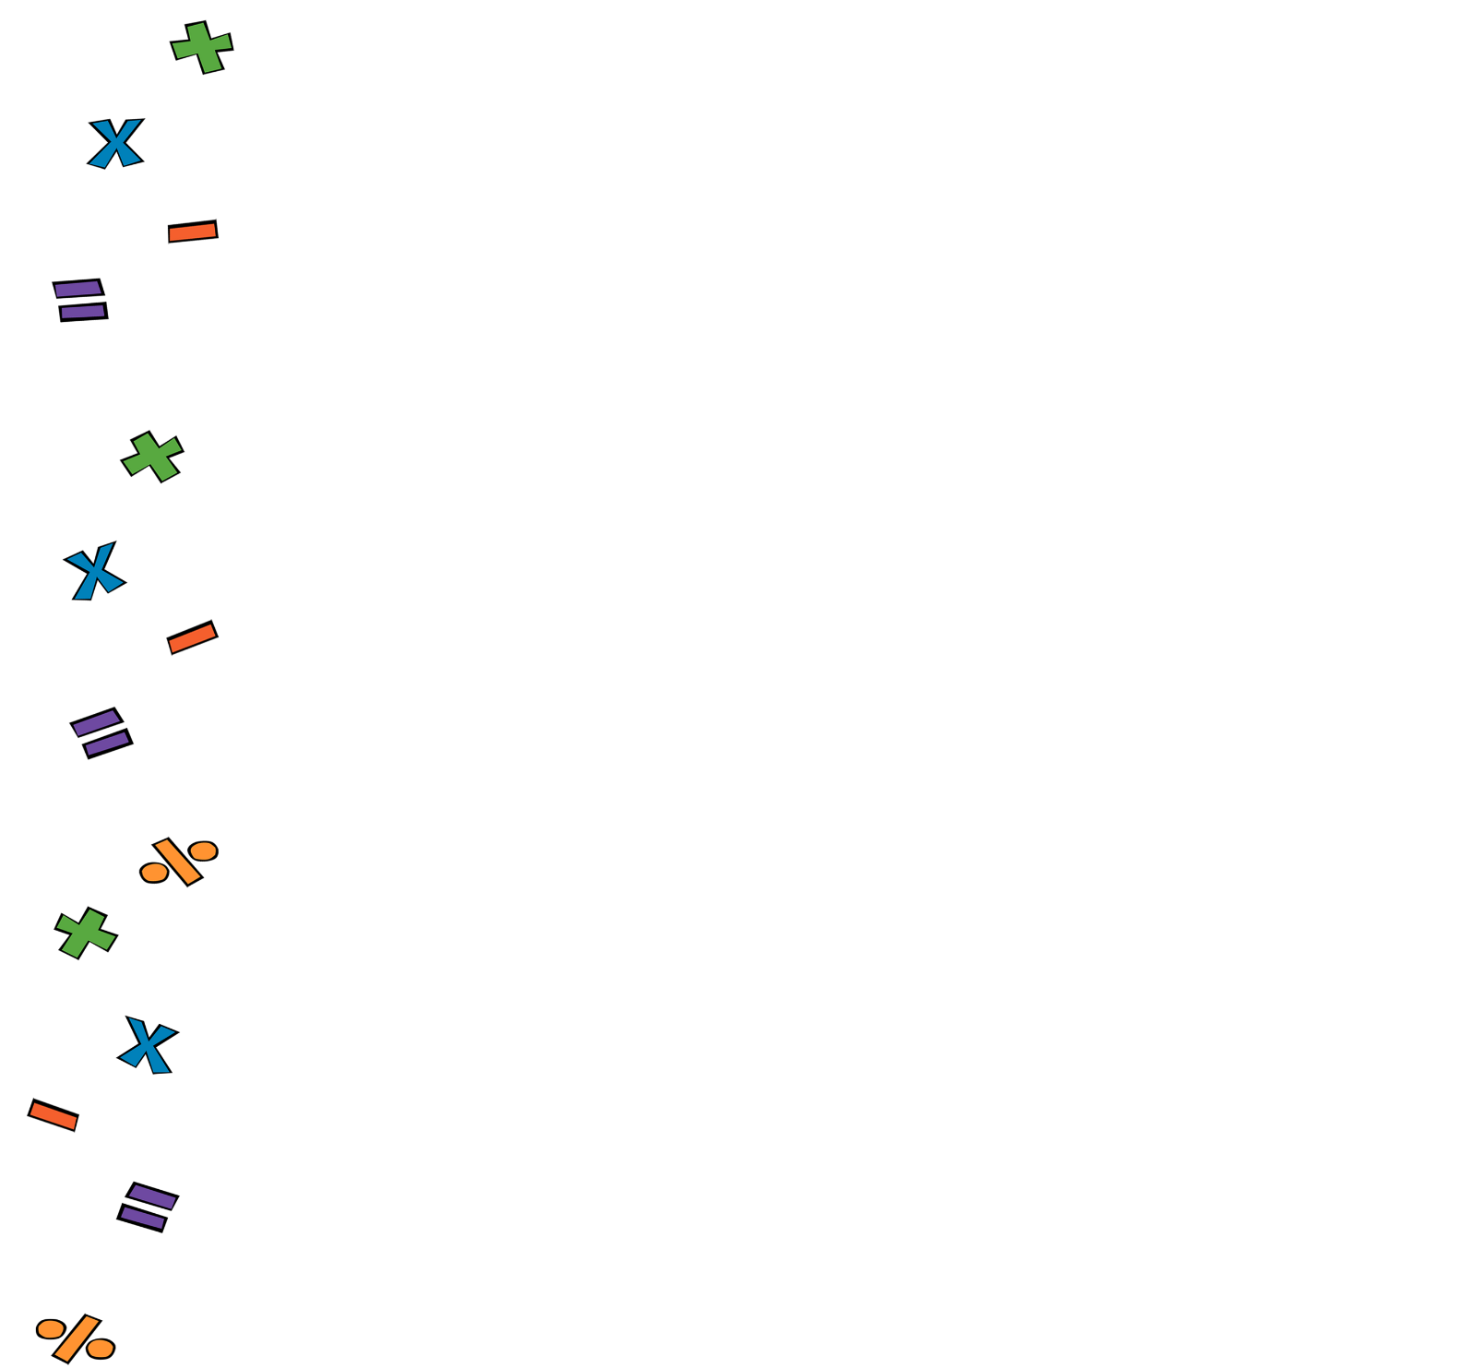

1. **Arithmetic**. Work out:
2. **Percentages**. £500 are invested at a 2% compound interest rate per year. Assuming no cash in withdrawn, how much money will there be in the account after 5 years?
3. **Linear Algebra**. Find the equations of the line passing through and :
4. **Quadratic Algebra.** Solve by using the quadratic formula () . Give your answer to 2 decimal places.
5. **Volume and Area**. The formula to work out the volume of a sphere is . Work out the radius of a sphere with volume . Give your answer to 3 significant figures.
6. **Pythagoras and Trig**. Find the value of . Give your answer to 1 decimal place.
7. **Statistics and Probability.** Data about the height of 30 tomato plants are summarised in the table below. Draw a cumulative frequency graph and use it to estimate the median and interquartile range.

|  |  |
| --- | --- |
| **Height, (cm)** | **Frequency** |
|  | 2 |
|  | 8 |
|  | 10 |
|  | 7 |
|  | 3 |



