**Fundamentals to Practice Going into yr 6**

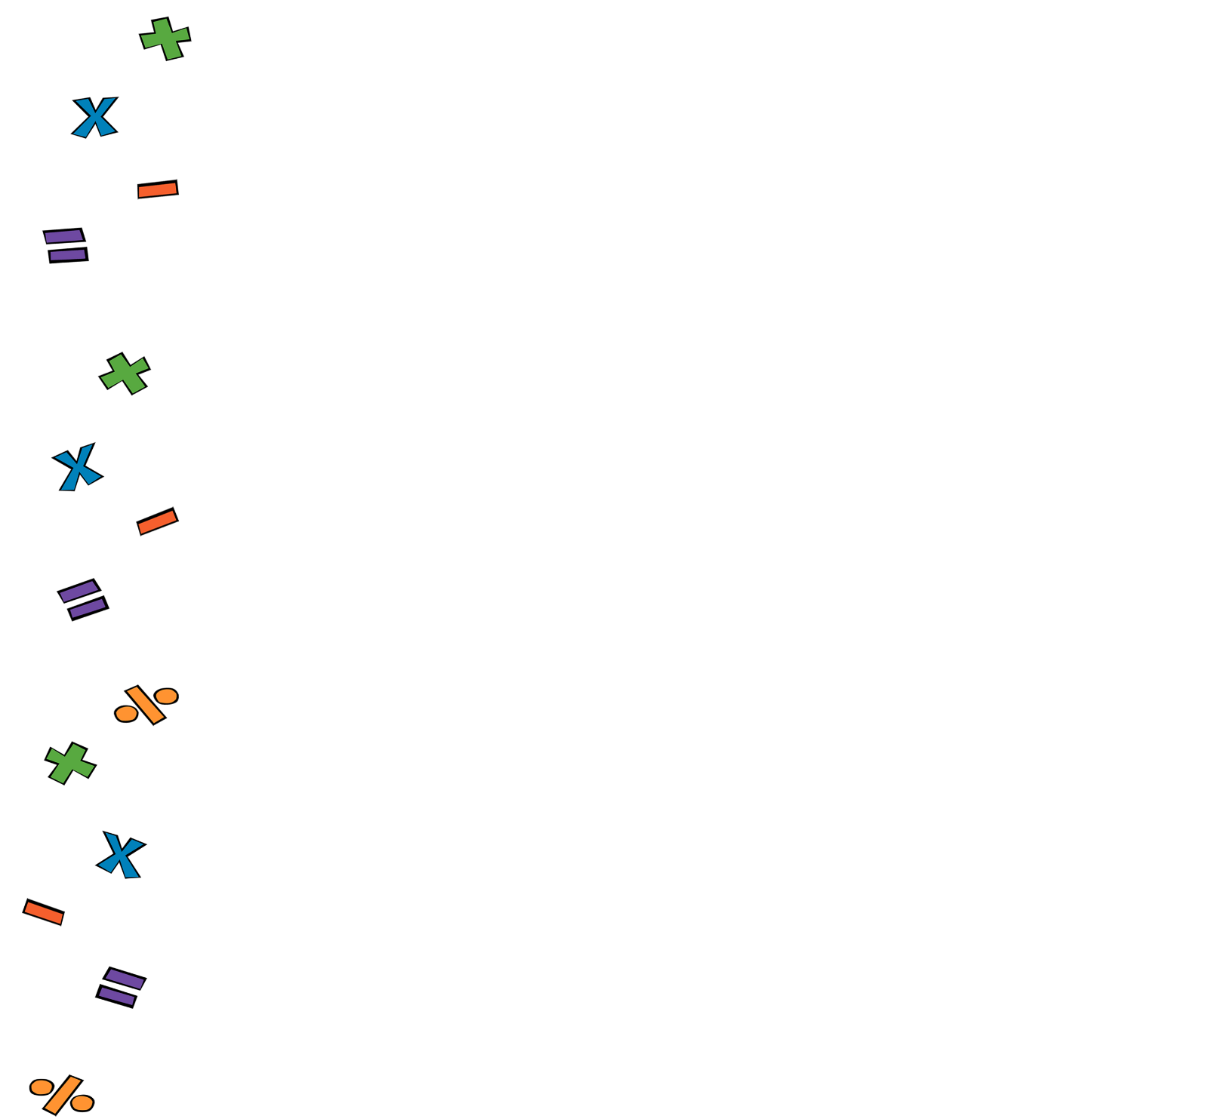

**Week 1: The 4 Operations**

