**Fundamentals to Practice Going into yr 11 (2)**

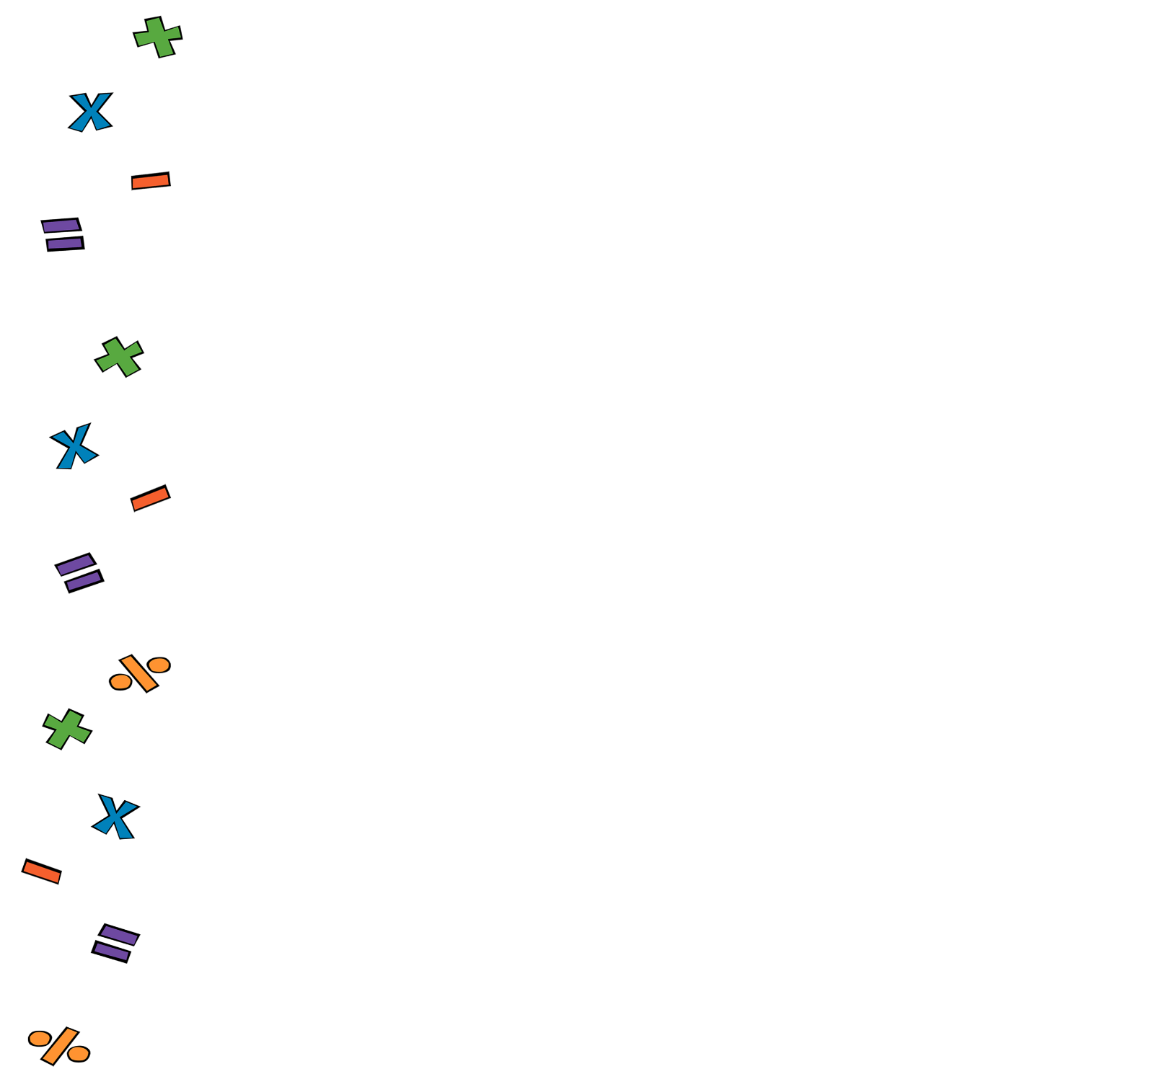

1. **Arithmetic**. Work out the following:
2. **Percentages**. In a school trip, 25 of the 60 total students are in year 7. What’s the percentage of students in year 7?
3. **Linear Alegebra**. Make the subject of the formula
4. **Quadratic Algebra.** Factorise:
5. **Volume and Area**. Work out the area of a circle with diameter measuring 4.6cm. Give your answer to 2 significant figures:
6. **Pythagoras and Trig**. Work out the side marked with

17 cm



1. **Statistics.** A statistician noted down the hights (in cm) of 5 football players. Find the median and the range.

178, 169, 180, 182, 172