**Fundamentals to Practice Going into yr 6**

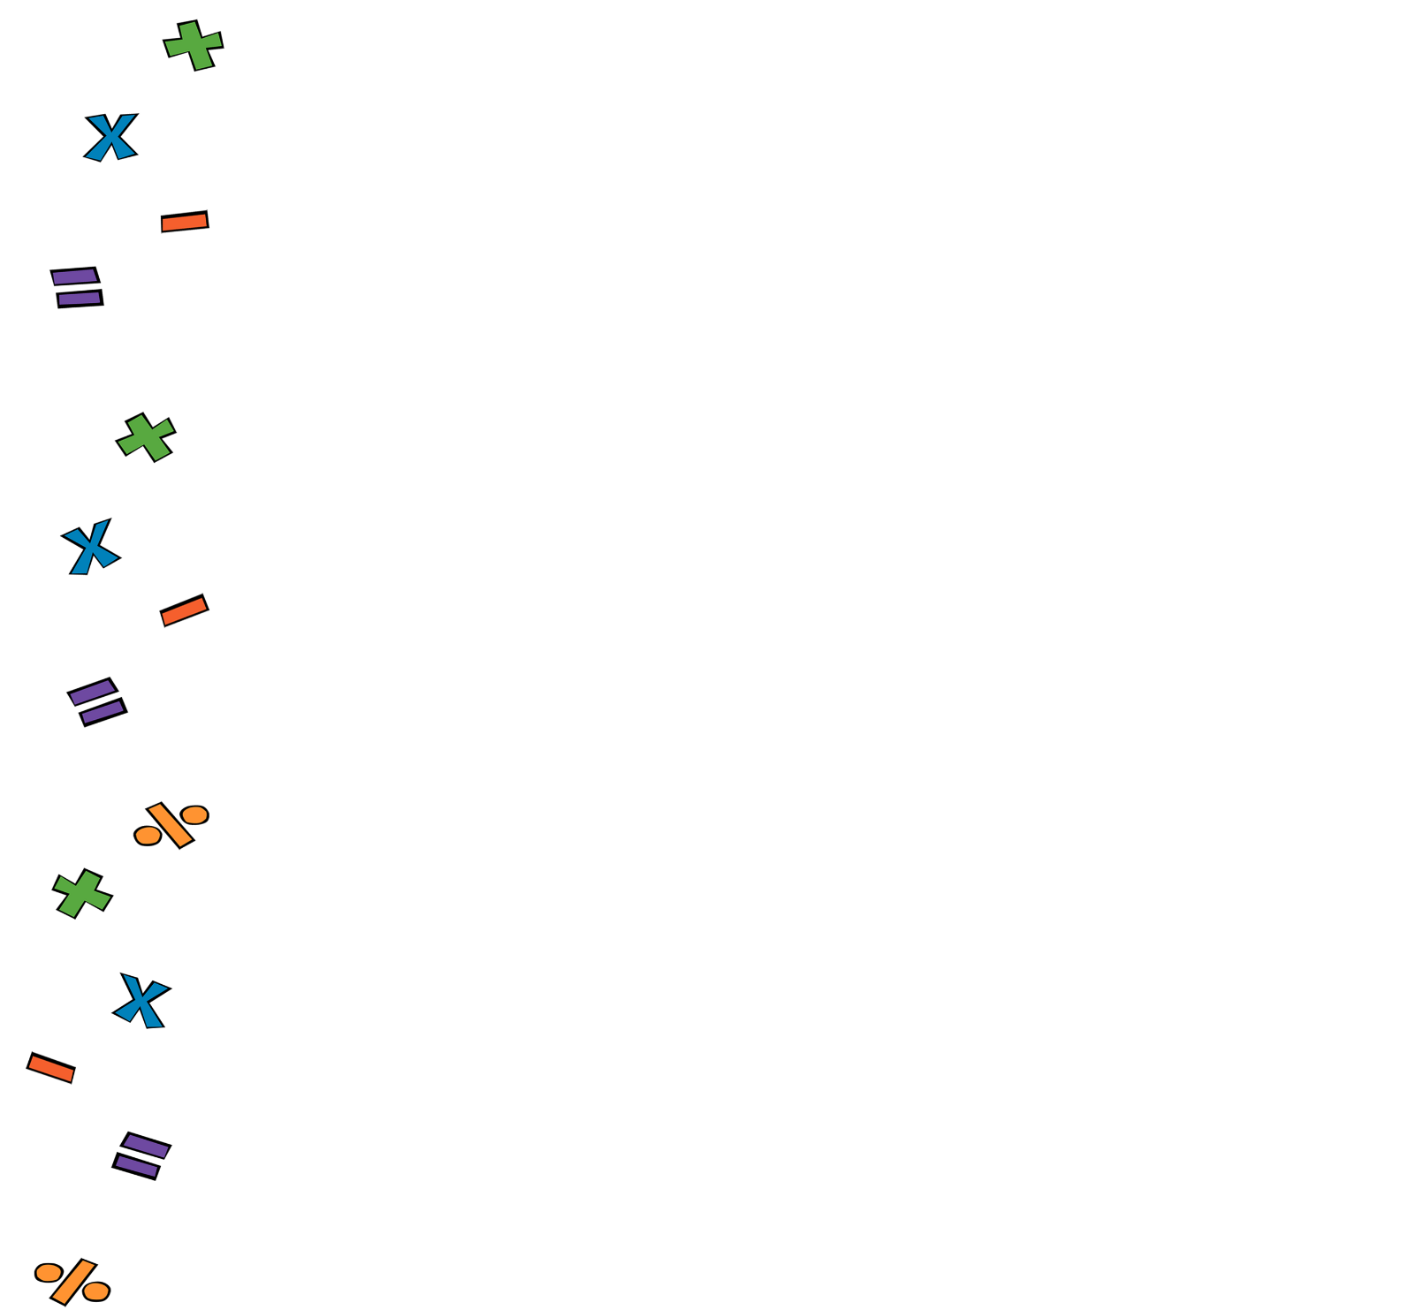

**Week 6: 4 Operations with Fractions**

