**Fundamentals to Practice Going into yr 11 (4)**

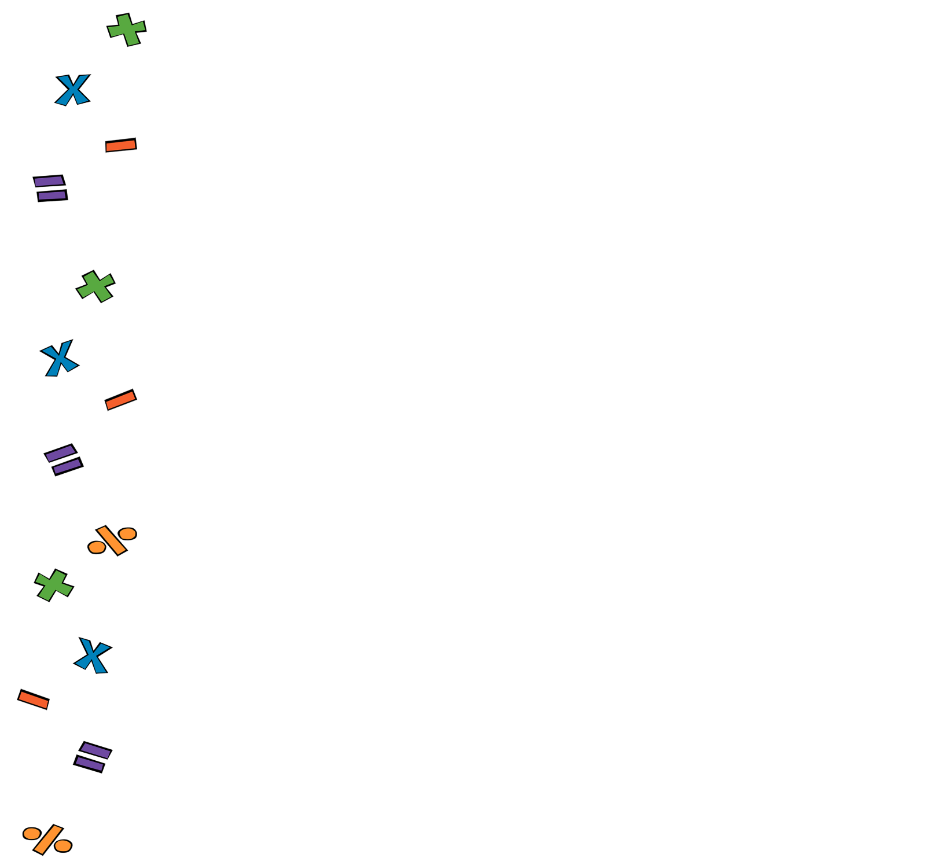

1. **Four Operations:**

Work out

1. **Fractions:**

Work out

1. **Linear Algebra**:

Factorise

1. **Perimeter and Area**.

Work out the area of the triangle below

7 cm

16 cm

1. **Statistics.** A statistician noted down the hights (in cm) of 5 football players. Work out the range

178, 172, 180, 182, 178