**Fundamentals to Practice Going into yr 11 (5)**

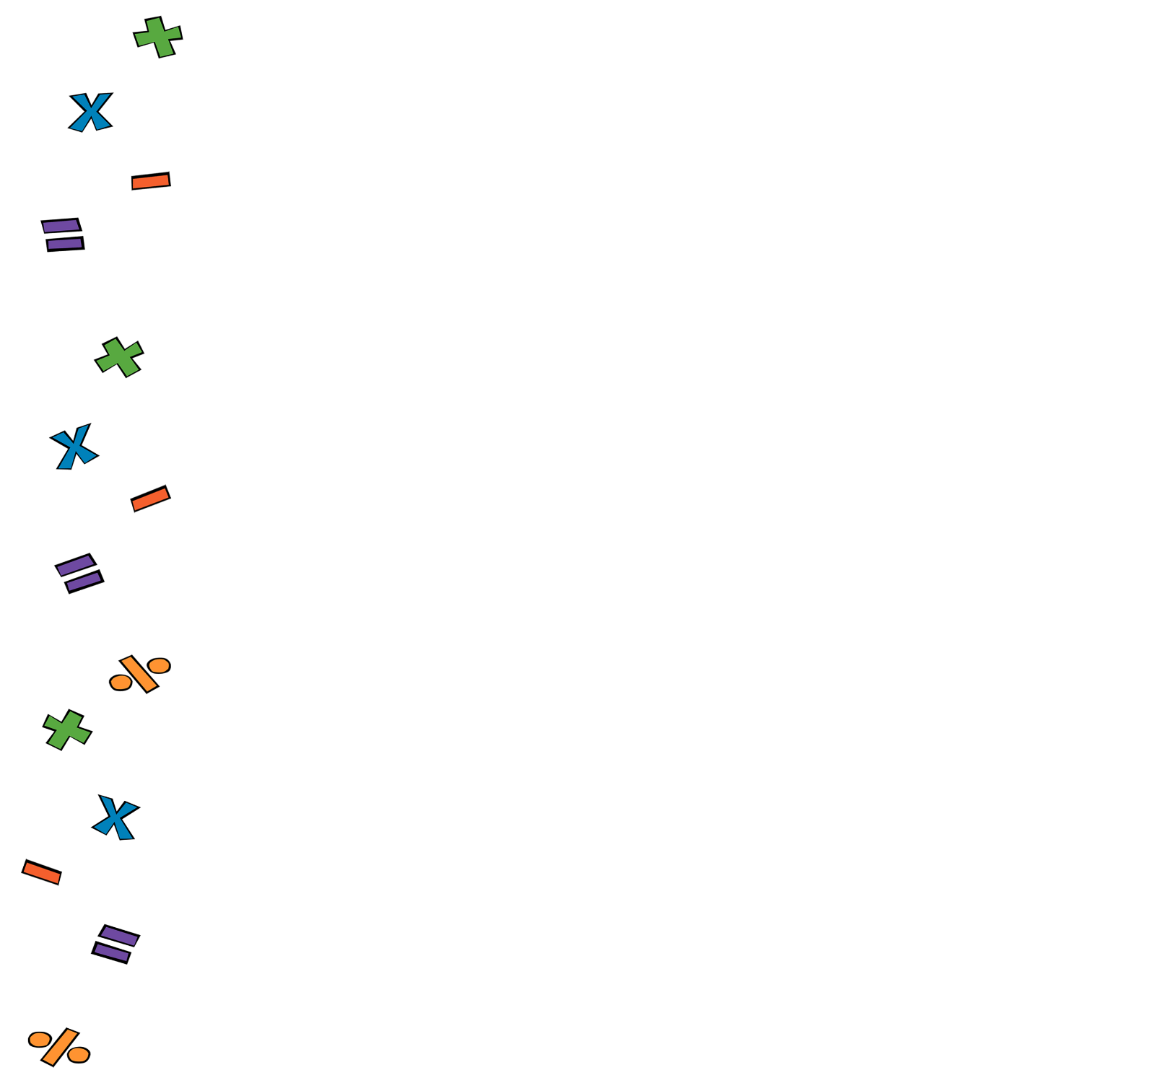

1. **Arithmetic**. Work out
2. **Percentages**. A suitcase is sold for £65 after a 10% discount. What was the original price of the suitcase?
3. **Linear Algebra**. Solve simultaneously:
4. **Quadratic Algebra.** Expand:
5. **Volume and Area**. The volume of a cube is . What’s its surface area?
6. **Pythagoras and Trig**. Work out the area of a equilateral triangle with sides measuring 14cm. Give your answer to 2 significant figures
7. **Statistics and Probability.** Data about the height of 30 tomato plants are summarised in the table below. Estimate the mean height. Give your answer to 1 decimal place..

|  |  |
| --- | --- |
| **Height, (cm)** | **Frequency** |
|  | 2 |
|  | 8 |
|  | 10 |
|  | 7 |
|  | 3 |