**Fundamentals to Practice Going into yr 11 (1)**

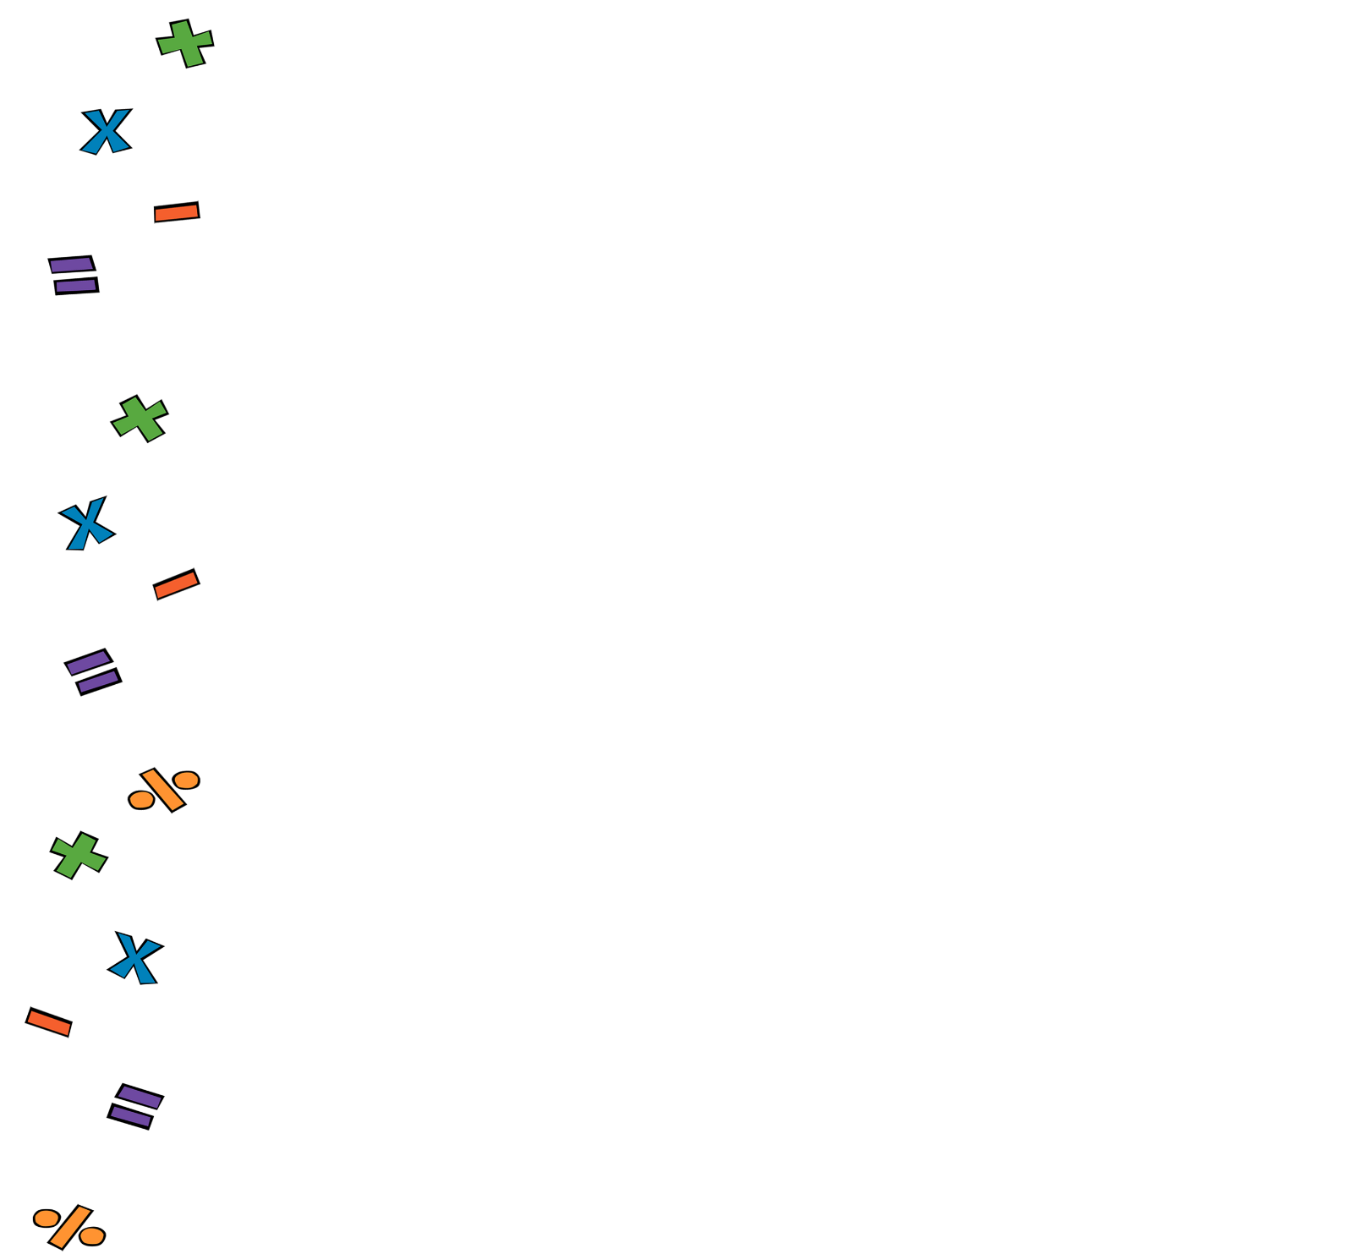

1. **Four Operations:**

Work out

1. **Fractions:**

Work out

1. **Linear Algebra**:

Simplify

1. **Perimeter and Area**.

Work out perimeter of the rectangle below:

9 cm

12 cm

1. **Statistics.** A statistician noted down the hights (in cm) of 5 football players. State the mode

178, 172, 180, 182, 178