**Fundamentals to Practice Going into yr 11 (4)**

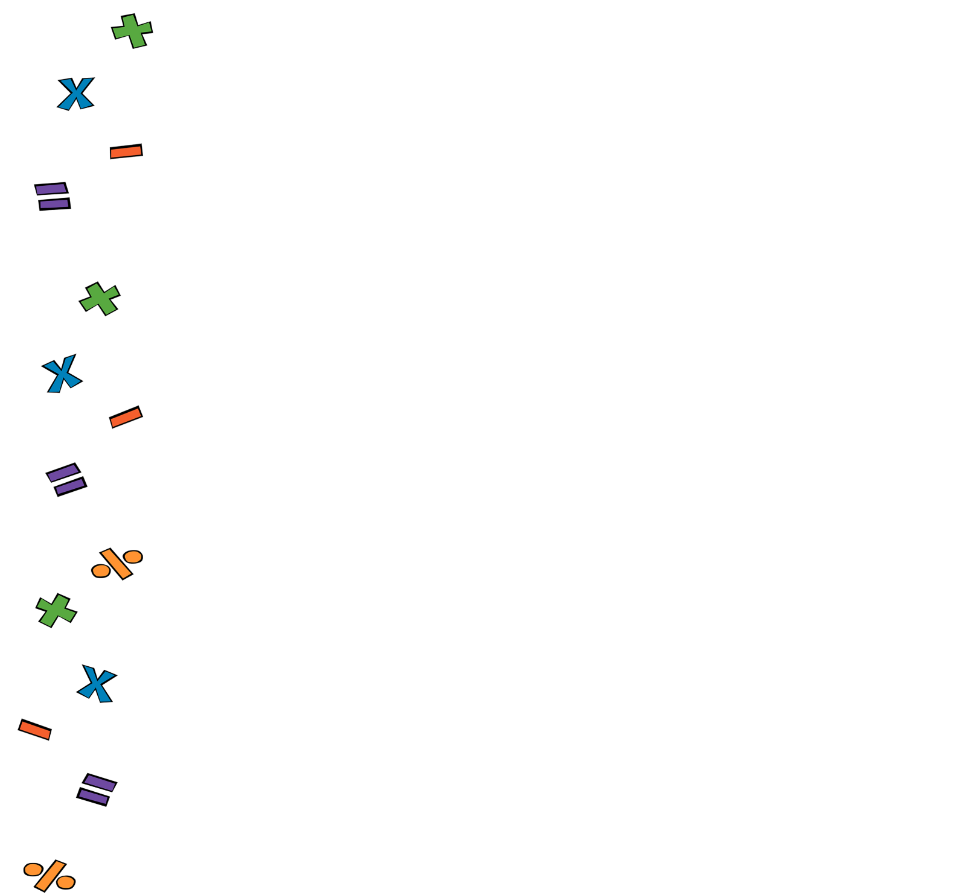

1. **Arithmetic**. Antony and Bob share £108 in the ratio 4:5. How much money does each of them get?
2. **Percentages**.
3. Increase 52 by 17%
4. Decrease 86 by 21%
5. **Linear Algebra**. Find the equation of the line that passes through point A(2, 8) with gradient 6,
6. **Quadratic Algebra.** Complete the table of points and plot the graph of :

|  |  |  |  |  |  |  |  |  |
| --- | --- | --- | --- | --- | --- | --- | --- | --- |
|  | -8 | -6 | -4 | -2 | 0 | 2 | 4 | 6 |
|  |  |  |  |  |  |  |  |  |

Use the squared paper on the next page

1. **Volume and Area**. The circumference of a circle is . What’s its radius?
2. **Pythagoras and Trig**. Work out the angle marked with . Give your answer to the nearest degree.



9.7 cm

15.6 cm

1. **Statistics and Probability.** Data about the shoe size of a group of students has been summarised in the table below. Work out the mean shoe size to the nearest half size.

|  |  |  |  |  |  |  |  |  |
| --- | --- | --- | --- | --- | --- | --- | --- | --- |
| Shoe Size | 4 | 4.5 | 5 | 5.5 | 6 | 6.5 | 7 | 7.5 |
| Frequency | 1 | 2 | 6 | 8 | 7 | 5 | 5 | 1 |



