**Fundamentals to Practice Going into yr 11 (3)**

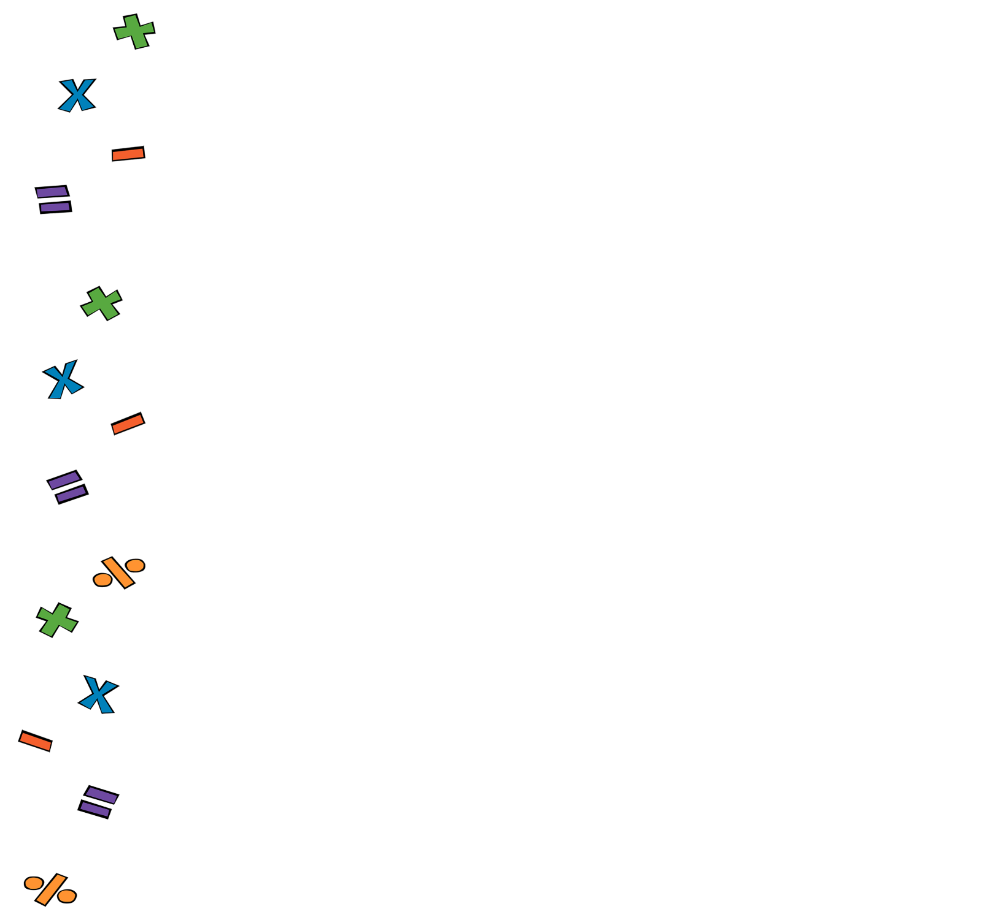

1. **Four Operations:**

Work out

1. **Fractions:**

Work out of 96

1. **Linear Algebra**:

Expand and simplify

1. **Perimeter and Area**.

What’s the perimeter of a regular octagon with sides measuring 17cm?

1. **Statistics.** A statistician noted down the hights (in cm) of 5 football players. Work out the mean

178, 172, 180, 182, 178