**Fundamentals to Practice Going into yr 6**

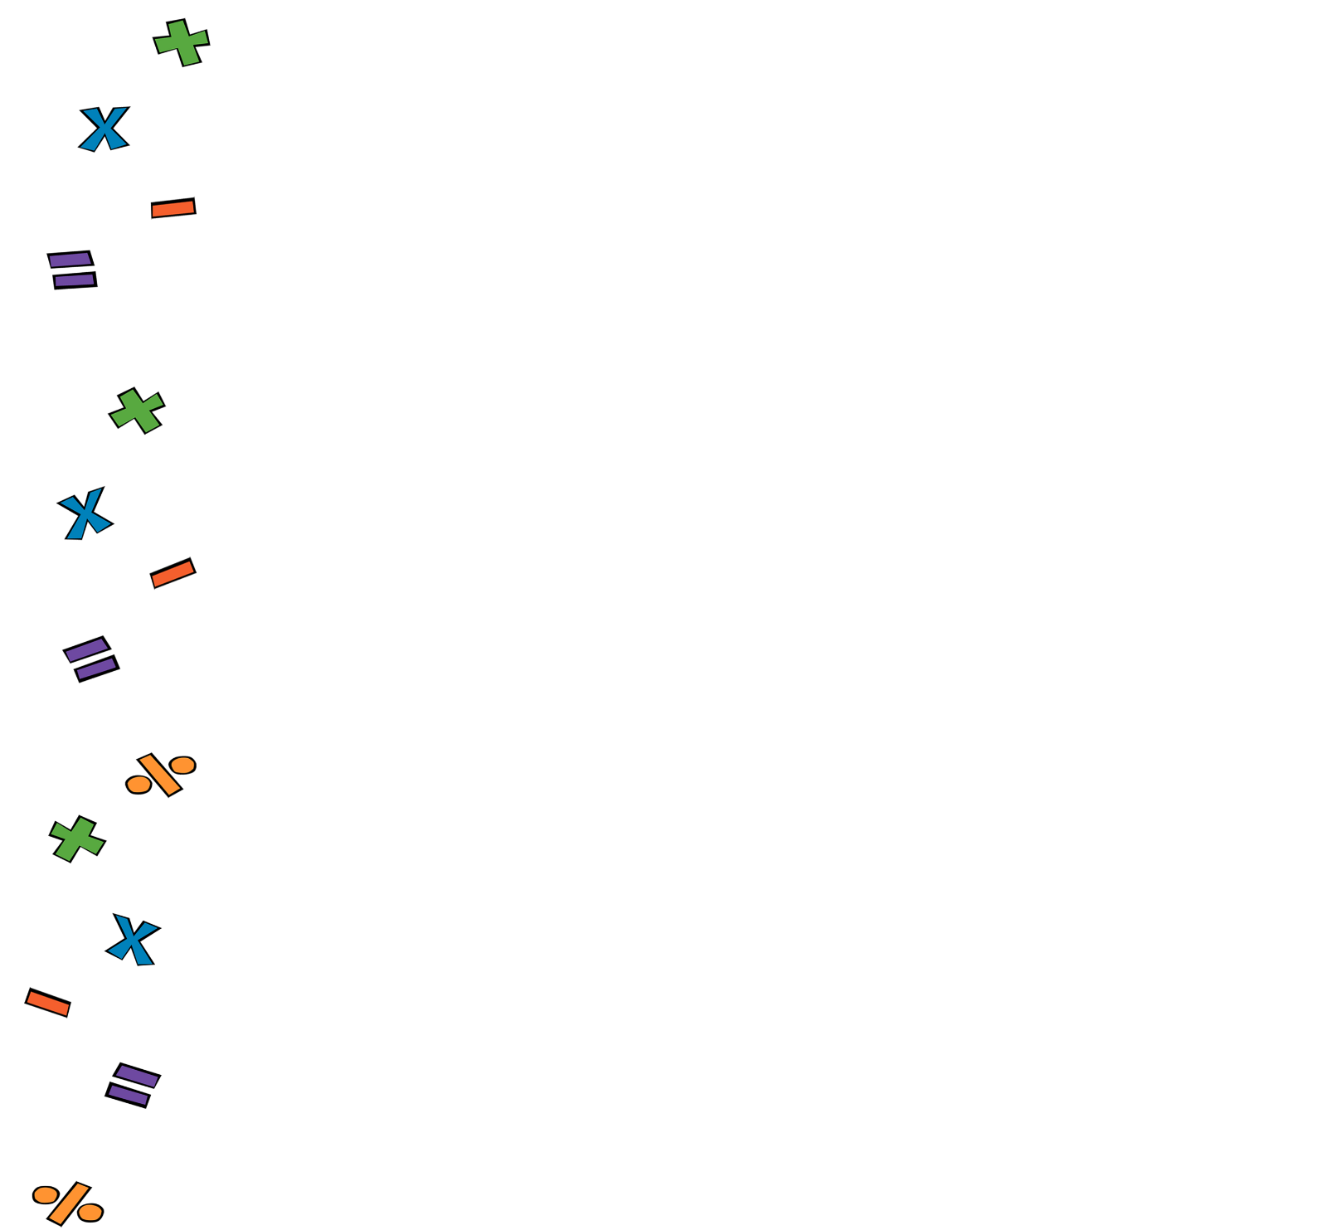

**Week 3: Reverse Operations**

