**Fundamentals to Practice Going into yr 11 (1)**

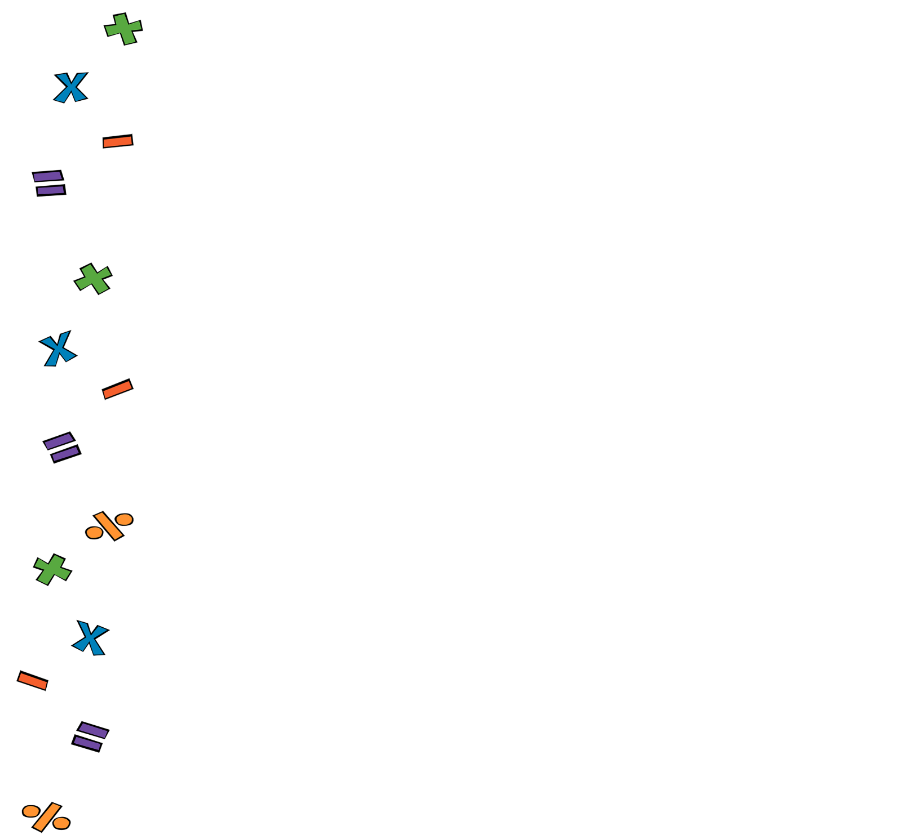

1. **Arithmetic**. Work out the following
2. **Percentages**. A t-shirt that would normally cost £27 is sold with a 12% discount. What’s the discounted price of the t-shirt?
3. **Linear Alegebra**.
4. Expand and simplify:
5. Solve:
6. **Quadratic Algebra.** Expand and simplify:
7. **Volume and Area**. Work out the area of the triangle below:

9 cm

12 cm

1. **Pythagoras and Trig**. Work out the hypotenuse of a right angled triangle with perpendicular sides of length 5cm and 12cm respectively
2. **Statistics.** A statistician noted down the hights (in cm) of 5 football players. Work out the mean.

178, 169, 180, 182, 172