**Fundamentals to Practice Going into yr 11 (5)**

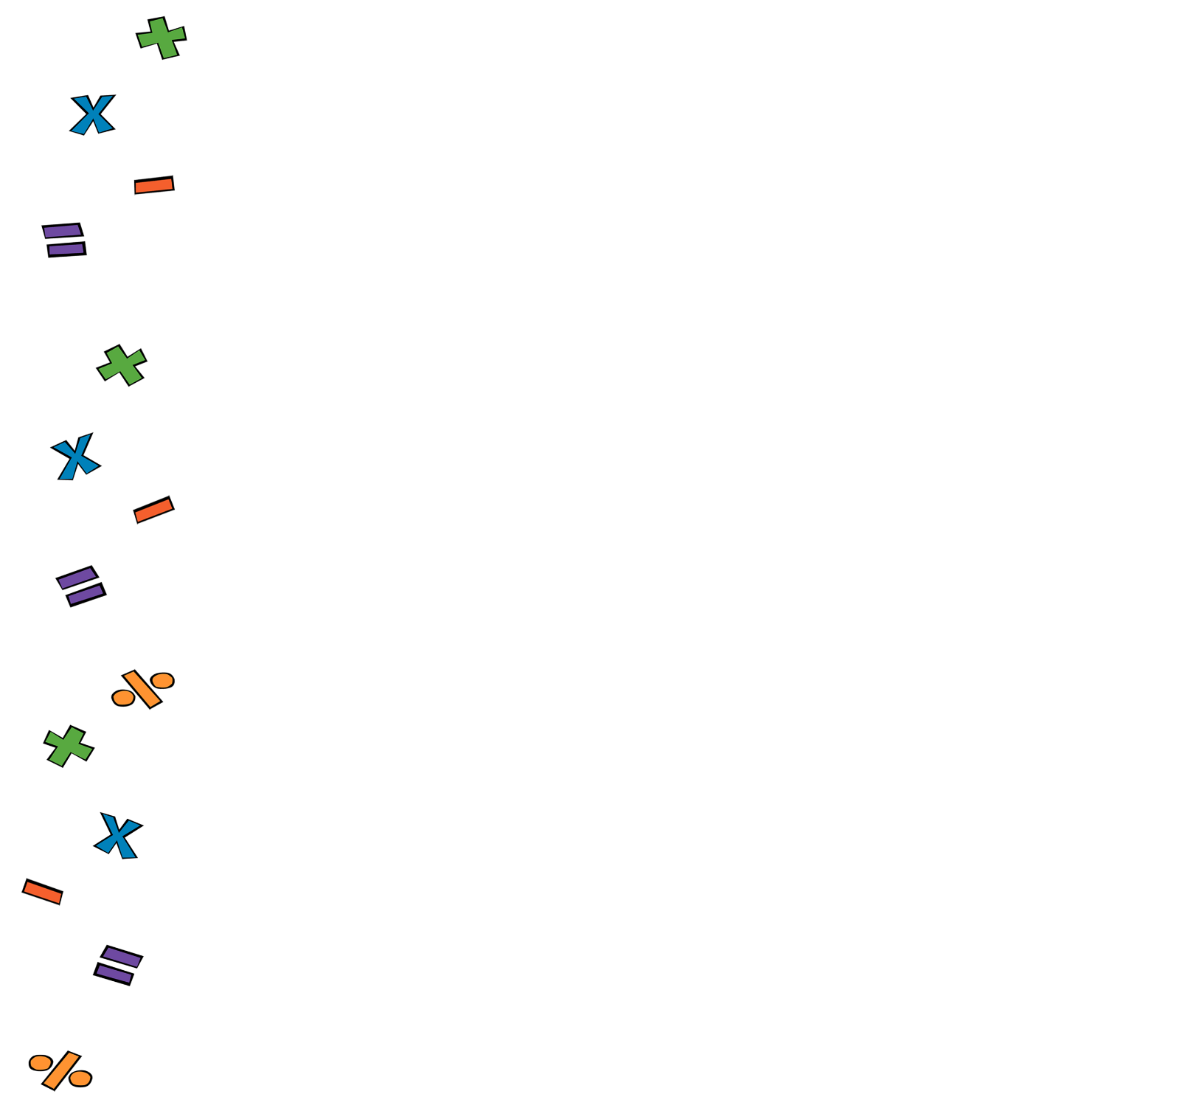

1. **Four Operations:**

Work out

1. **Fractions:**

Work out

1. **Linear Algebra**:

Solve

1. **Perimeter and Area**.

The area of a play area is 72 m2 . Its width is 9 m. What’s its length?

1. **Statistics.** Here is some data about the shoe side of a group of 20 students summarised in a frequency table. What’s the mode shoe size?

|  |  |
| --- | --- |
| Shoe Size | Frequency |
| 4 | 2 |
| 5 | 3 |
| 6 | 8 |
| 7 | 4 |
| 8 | 3 |