**Numerical Solutions**

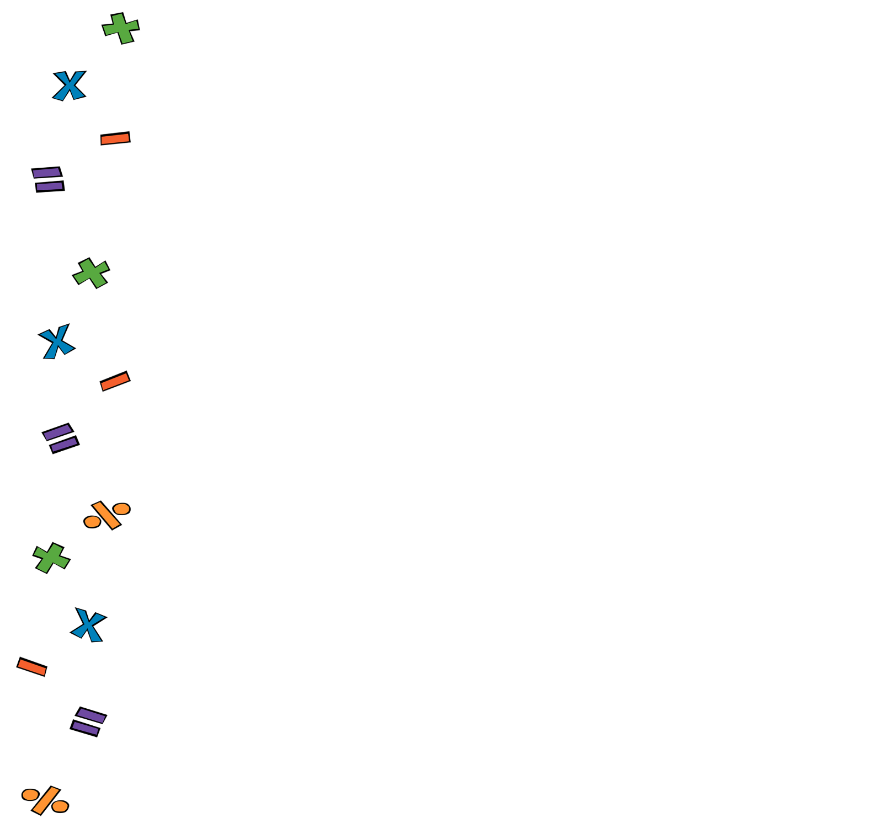

1. a) , b) , c) , d)
2. £23.76
3. a) , b)
4. 54 cm2
5. 13 cm
6. 176.2 cm

**Week 2**

1. a) 18.33, b) 22.4
2. 41.7% to 1decimal place
3. 17 cm2
4. 14.4 cm to 1 decimal place
5. Median = 178 cm, range=13 cm

**Week 3**

1. 12
2. £31.13
3. a) , b)
4. 630 cm3
5. 13.7 cm
6. 8 times

**Week 4**

1. £48 and £60
2. a) 80.84, b)67.94
3. values from left to right: 98, 60, 30, 8, -6, -12, -10, 0
4. 6

**Week 5**

1. £72.22
2. 150 cm2



1. 85 cm2
2. 48.7cm

**Week 6**

1. -2, -10, +10, -5
2. £552.04
4. 3.94cm